# **Mount Vulnerable PC (Windows7)**

## ***1. Import OVA file (Vulnerable PC(Win7).ova)***

- File - Import Appliance - Select Vulnerable PC(Wi7) Image

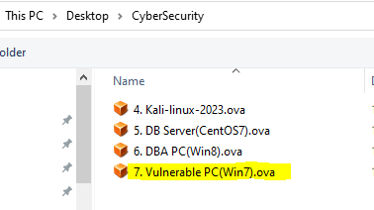

- After importing, you can see DBA PC in the VM list

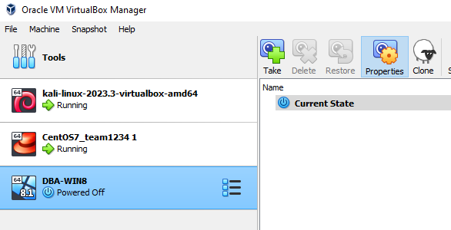

***2. Check network***

- Run DBA PC

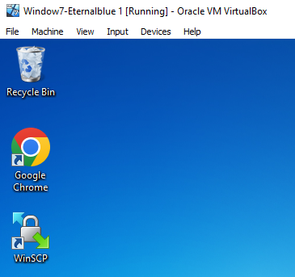

- Open Terminal:

Press Windows Key + R

cmd

ipconfig

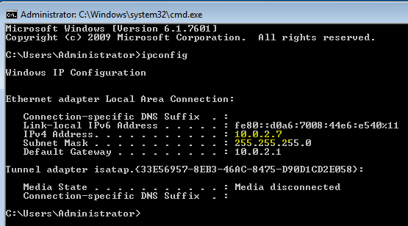

* IP is 10.0.2.7

- Check Internet connection

DBA PC> ping google.com

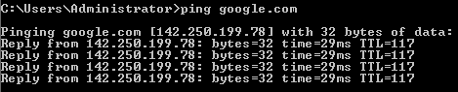

***3. Check SSH-Server connection***

- Run WinSCP

1. Double click WinSCP

2. Click 'Open'

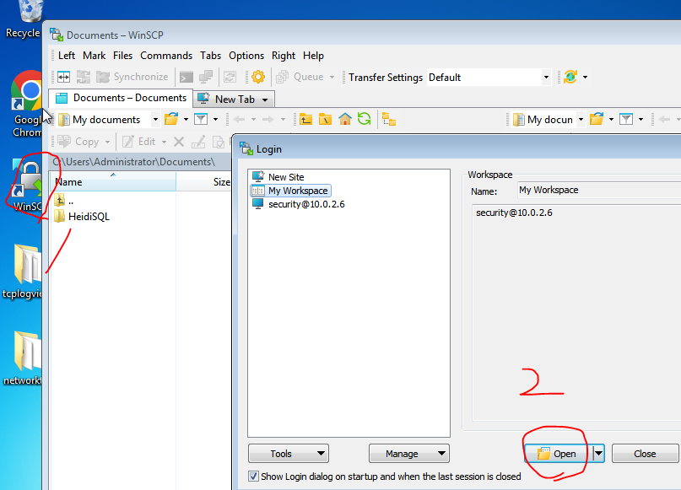

- If it is displayed, everything is ready.

